Question - Shell Scripting

Create two folders named abc xyz …( I am using D_folder1 and D_folder2)

Using shell script

Create a file in folder 1

Create a file in folder 2
Create a new folder in folder1 mkdir ( sub_folder1)
Create a new folder in folder 2 mkdir ( sub_folder2)
Implement cp , mv , rm , echo pwd

#!/bin/bash

#echo "Hi"

touch abc.txt
echo "abc file is created"

folder1_path="/home/neha_ubuntu/D_folder1"
folder2_path="/home/neha_ubuntu/D_folder2"

#check if folders already exist and remove to prevent any errors in creating folders

if [ -d "$folder1_path" ]; then
echo "Directory $folder1_path exists"
rm -r "$folder1_path"
echo "D_folder1 is deleted"
else
echo "Directory does not exist $folder1_path"

fi

if [ -d "$folder2_path" ]; then
echo "Directory $folder2_path exists"
rm -r "$folder2_path"
echo "D_folder2 is deleted"
else
echo "Directory does not exist $folder2_path"

fi

#create two folders - D_folder1 and D_folder2

mkdir "$folder1_path"
echo "D_folder1 created"

mkdir "$folder2_path"
echo "D_folder2 created"

#create files in both folders
touch /home/neha_ubuntu/D_folder1/f1.txt
echo "file created in D_folder1"

touch /home/neha_ubuntu/D_folder2/f2.txt
echo "file created in D_folder2"

#create sub-folders in D_folder1 and D_folder2

mkdir /home/neha_ubuntu/D_folder1/sub_folder1
echo "folder created in D_folder1"

mkdir /home/neha_ubuntu/D_folder2/sub-folder2
echo "a new folder is created in D_folder2"

cp /home/neha_ubuntu/abc.txt /home/neha_ubuntu/D_folder1/sub_folder1/abc.txt
echo "abc file copied"

touch mvfile.txt
echo "file is created to apply mv command"

mv /home/neha_ubuntu/mvfile.txt /home/neha_ubuntu/D_folder2/
echo "file is moved to a different folder"

touch /home/neha_ubuntu/removefile.txt
echo "removefile.txt is created"

rm /home/neha_ubuntu/removefile.txt
echo "file is removed"

echo "show the present directory"
pwd

rm -r /home/neha_ubuntu/D_folder1
echo "removed D_folder1"

Output:-
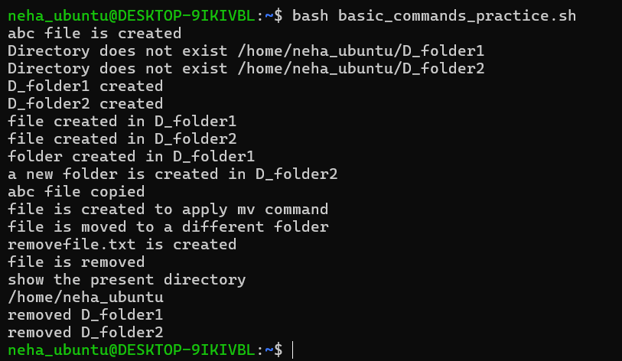

—---------------------------------------------------------------------------------------------------------------------------

Introduction to Linux & Basic Commands

Topics:
• File system structure (/home, /etc, /bin, etc.)
• Basic commands: pwd, ls, cd, mkdir, rmdir, cp, mv, rm

Assignment:
1. Create a directory structure like /home/student/linux_basics/day1.

#!/bin/bash

echo "create directory structure -- /home/student/linux_basics/day1 "

mkdir -p /home/neha_ubuntu/Assignment_Folder/Day1/linux_basics/day1

echo "folder created"

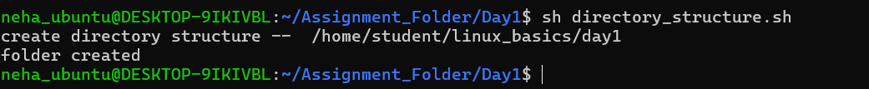

2. Inside it, create 3 text files and move them into a subfolder called data.

#!/bin/bash

echo "create 3 text files and move them into a subfolder called data"

touch text_file1.txt text_file2.txt text_file3.txt

mkdir /home/neha_ubuntu/Assignment_Folder/Day1/data

mv text_file1.txt text_file2.txt text_file3.txt /home/neha_ubuntu/Assignment_Folder/Day1/data

echo "all 3 text files are moved to data folder"

3. Use ls -l and redirect output to a file named output.txt.

ls -l > output.txt

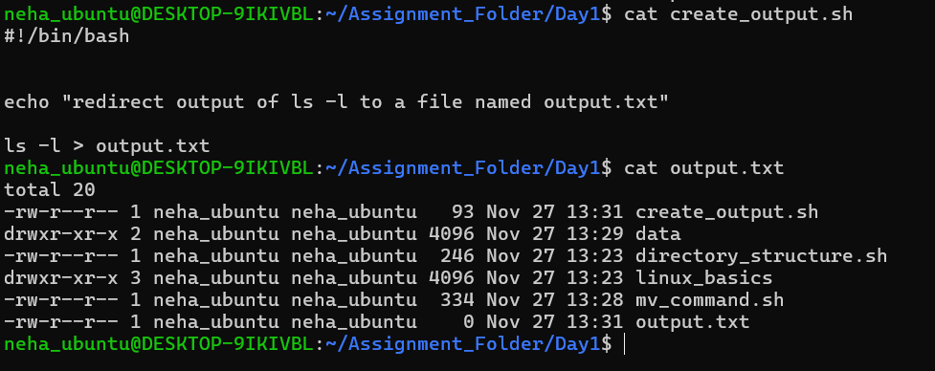

Challenge:
• Combine commands with && and ; to perform multiple actions in one line.

#!/bin/bash

Path="/home/neha_ubuntu/linux_basics"

echo $Path

if [ -d "$Path" ]; then
echo "Directory already exists"
rm -r "$Path"
echo "linuc_basics is deleted"
else
echo "Directory does not exist $Path"
fi

echo "create 3 text files and generate output file"

mkdir -p /home/neha_ubuntu/linux_basics/day1 ; cd /home/neha_ubuntu/linux_basics/day1 && touch file1.txt file2.txt file3.txt ; mkdir Data && mv file1.txt file2.txt file3.txt /home/neha_ubuntu/linux_basics/day1/Data/ ; cd /home/neha_ubuntu/linux_basics/day1/Data && ls -l > /home/neha_ubuntu/linux_basics/day1/output.txt

echo "output file is generated"

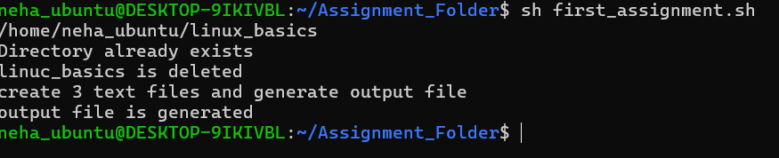

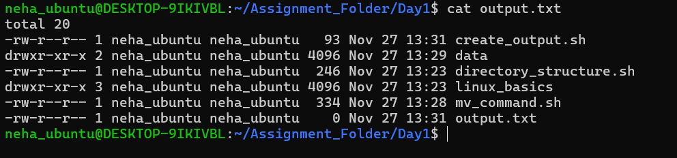

Working with Files & Permissions

Topics:
• File viewing and editing (cat, less, more, nano, vi)
• Permissions (chmod, chown, chgrp)

Assignment:
1. Create a file report.txt and write some content using nano or vi.
2. Change its permission so only the owner can read and write.
3. Create a new user and transfer file ownership to that user.

Challenge:
• Use symbolic and numeric permission changes.

#!/bin/bash
echo "Second Assignment"
touch report.txt
echo "report file is created"
ls -l report.txt
echo "read , write permission only to user"
chmod 600 report.txt
ls -l report.txt
echo "add user ..."
sudo useradd -m -s /bin/bash mneha
echo "secondassuser is created"
sudo chown mneha report.txt
echo "owner changed"

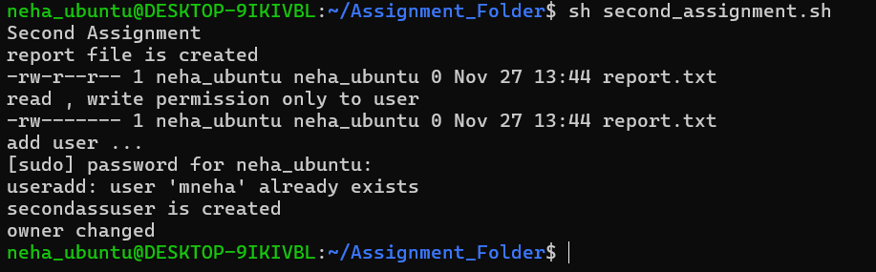

File Searching and Text Processing

Topics:
• Searching files: find, locate, grep, which
• Text utilities: head, tail, sort, uniq, wc

Assignment:
1. Create a folder with 5 .log files containing random text.
2. Use grep to find a specific word in all files.

grep -r “word_pattern” file or directory
grep -r -i “word_patter” file or directory –case insensitive

3. Find total word count in each file.

wc -w filename or directory

Challenge:
Use find with -exec to perform an action on each file automatically.

#!/bin/bash
echo "Third Assignment"

echo "Grep to find a specific word in all files"
grep -r -i "trees" /home/neha_ubuntu/Log_Files_Folder/

echo "total word count in each file"
wc -w /home/neha_ubuntu/Log_Files_Folder/*.log

echo "Using find and exec to perform above tasks"
find . -iname "*.log" -exec grep -r -i "trees" {} \; && find . -iname "*.log" -exec wc -w {} \;

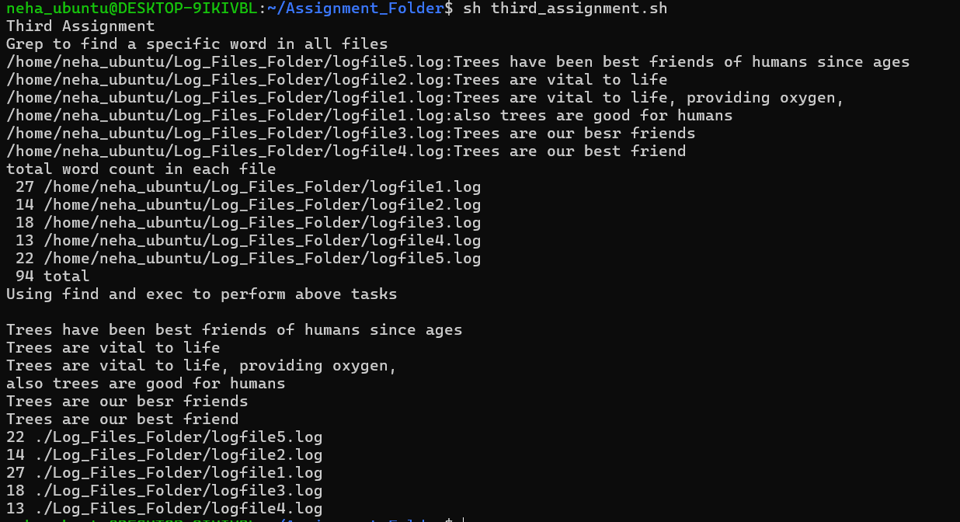

Note
Format of -exec option. It is used with find command .

find <path> <condition> -exec <command> {} \;

{} placeholder for each matched file
\; end the -exec command

find . -name "filename.txt": Finds a file named "filename.txt"

Redirection , pipes and filters

Topics:
• Input/output redirection (>, >>, <, 2>)
• Piping (|)

Assignment:
1. Redirect output of ls -l to a file.

ls -l > output.txt

2. Pipe the output of cat into grep to find matching patterns.

cat /home/neha_ubuntu/Output.txt | grep ".txt"

3. Combine sort, uniq, and wc to find unique lines and count them.

sort /home/neha_ubuntu/Output.txt | uniq | wc -l

Challenge:
• Combine at least 3 commands using pipes to process a text file.

#!/bin/bash
echo "redirect output of ls -l to file"
ls -l > /home/neha_ubuntu/Output.txt

echo "pipe output to grep"
cat /home/neha_ubuntu/Output.txt | grep ".txt"

echo "sort, uniq, wc using pipe"
sort /home/neha_ubuntu/Output.txt | uniq | wc -l

echo "fourth assignment is done"

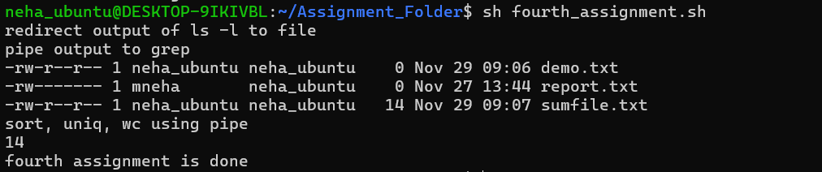

Environment Variables & System Info

Topics:
• System info: uname, top, df, du, uptime, who
• Environment variables (env, export, PATH)

Assignment:
1. Print system information and redirect to system_report.txt.

uname -a > system_report.txt

2. Create and export a custom variable named MYNAME.

export MYNAME = “neha”

3. Add your custom variable permanently in .bashrc.
sudo vim ~/.bashrc

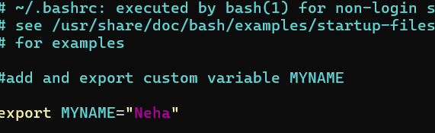

Now check if you have added custom variable MYNAME as below

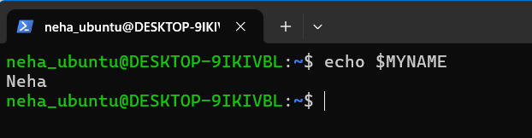

Challenge:
• Write a one-liner that prints your username, home directory, and shell.

Shell Scripting Basics

Topics:
• Writing and executing .sh file
vim script.sh
To execute sh script.sh or ./script.sh

• Variables, echo, read, comments

Assignment:
1. Create a script greet.sh that takes your name as input and prints a greeting.

#!/bin/bash
read -p "Enter your name:- " name
echo "Good morning, $name !"

2. Make it executable and run it.

chmod +x greet.sh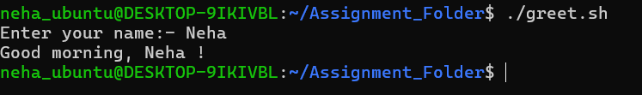

Challenge:

Modify the script to greet based on the current time (morning/afternoon/evening).

#!/bin/bash
echo "enter your name as input"
read your_name
echo "enter current time of day for a greeting"
read current_time
echo "Hi, $your_name , Good $current_time !"

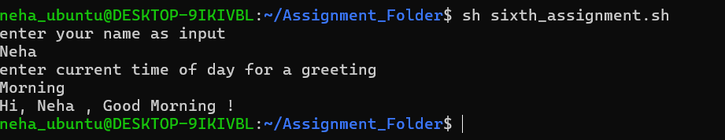

Conditional Statements

Topics:
• if, else, elif, test conditions [ ], [[ ]]

Assignment:
1. Write a script check_file.sh that checks if a file exists.
2. Print “File exists” or “File not found”.

#!/bin/bash
echo "check if a file exists or not"
Read -p “enter file name ” file_name
file_path="/home/neha_ubuntu/Assignment_Folder/$file_name"
echo "file_path $file_path ..."
if [ -f "$file_path" ];then
echo "file exists $file_path"
else
echo "file does not exist"
fi

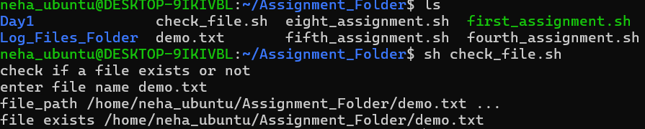

Challenge:
• Extend it to check if the file is readable, writable, or executable.

#!/bin/bash

echo "check if a file exists or not"
file_path="/home/neha_ubuntu/Output.txt"
echo "file_path $file_path ..."
if [ -f "$file_path" ];then
echo "file exists $file_path"
else
echo "file does not exist"
fi

echo "chech if a file is readable"

if [[ -r "$file_path" ]]; then
echo "readable"
else
echo "not readable $file_path"
fi

echo "check if a file is writable"

if [ -w "$file_path" ];then
echo "writable"
else
echo "cant write to a file"
fi

echo "check if we can execute a file"

if [ -x "$file_path" ]; then
echo "we can execute a file"
else
echo "not executable "

fi

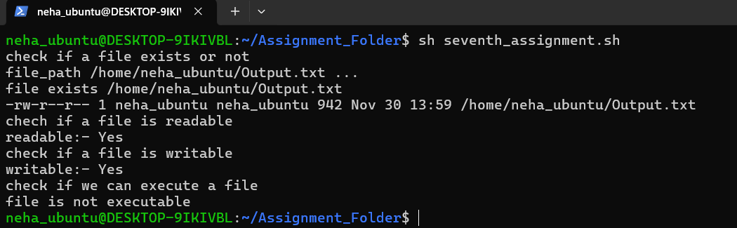

Loops in Shell

Topics:
• for, while, until loops

Assignment:
1. Write a script to print numbers from 1 to 10.
2. Use a loop to list all .txt files in a folder.

#!/bin/bash

echo "print number from 1 to 10 using for loop"

for number in 1 2 3 4 5 6 7 8 9 10
do
echo "number is $number"
done

echo "use while loop to print nos"

no=1

while [ $no -le 10 ];
do
echo "number: $no"
no=$((no+1))
done

echo "now use until loop to print nos from 1 to 10"

no1=1

until [ $no1 -eq 11 ]; do
echo " number is = $no1"
no1=$((no1+1))
done

echo "use loop to list all .txt files in a folder"

path="/home/neha_ubuntu"

echo "path of a folder is $path"

pwd

for file in *.txt;
do
echo " text file $file"
done
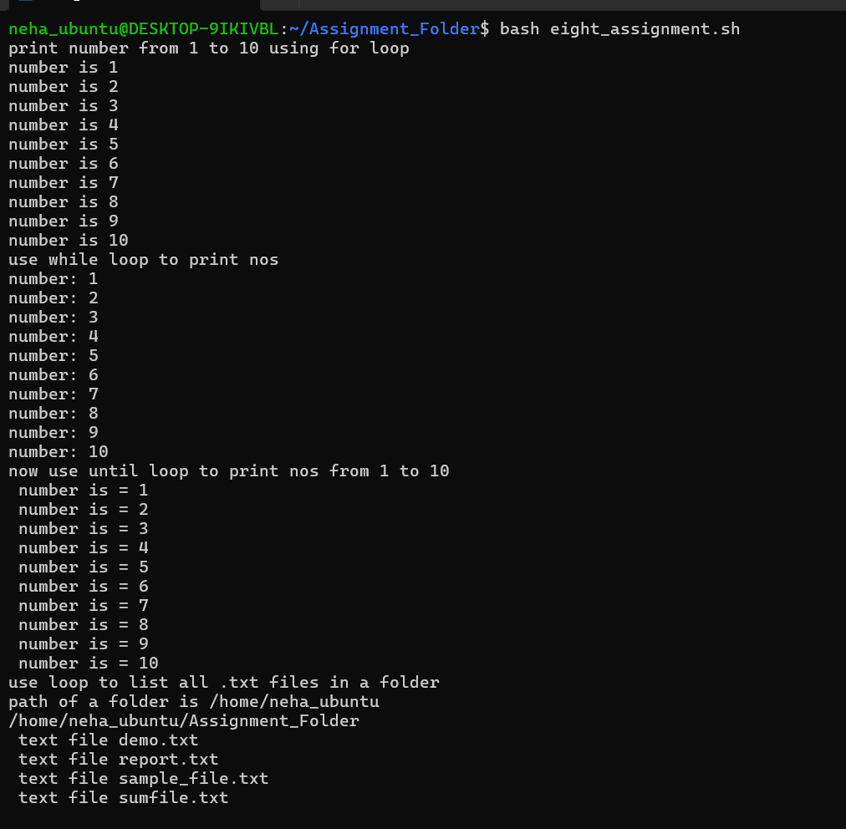

Challenge:
• Write a script to calculate the sum of all numbers in a file.

#!/bin/bash
input_file="/home/neha_ubuntu/Assignment_Folder/sumfile.txt"
IFS=$'\n'
sum_for=0
for line in $(cat "$input_file")
do
echo "no $line"
sum_for=$((sum_for + line))
done

echo "sum using for loop:- $sum_for"
unset IFS

sum_while=0
while IFS= read -r num; do
echo "num- $num"
sum_while=$((sum_while + num))
done < "$input_file"

echo "sum using while loop:- $sum_while"

cat /home/neha_ubuntu/Assignment_Folder/sumfile.txt | xargs -n1 | awk '{s+=$1} END {print s}'

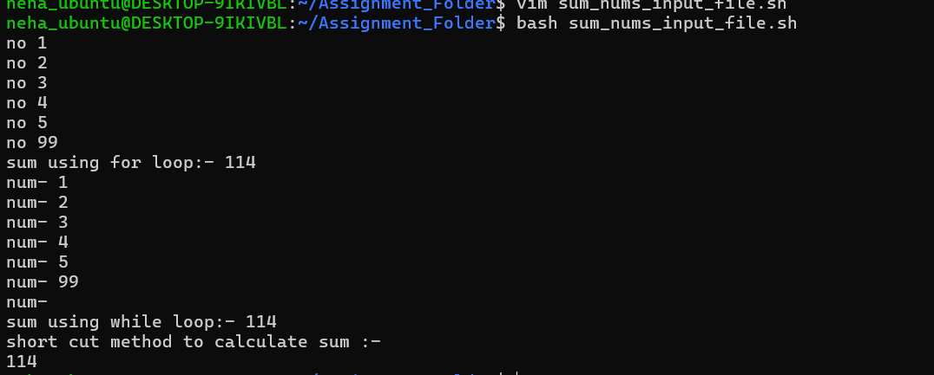

Functions & Command-Line Arguments

Topics:
• Functions
• $1, $2, $@, $# usage

Assignment:
1. Write a script with a function to calculate factorial of a number.

#!/bin/bash

echo "a function to calculate a factorial"

read -p "enter a number :- " number
function_factorial() {

echo "find factorial.."

fact=1

#echo "print fact - $fact and $num1 and $1"
num=$1

factor=1
for (( i=1; i<=$1; i++ ))
do
factor=$((factor * i))
done

echo "factorial of $number is $factor"

}

function_factorial $number

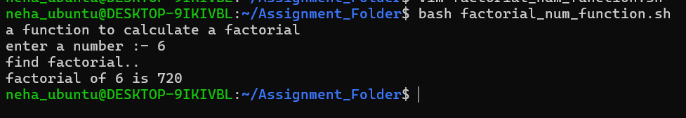

2. Pass the number as a command-line argument.

#!/bin/bash

echo "Function to pass the number as a command line argument"

functions_name() {

echo "the numbers are - $1 and $2"
echo "name of scriot is- $0"
}

functions_name 5 6

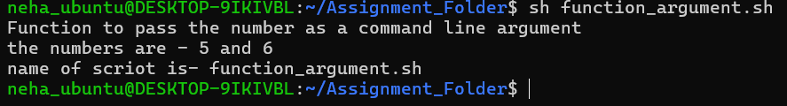

Challenge:
• Add input validation and error handling for missing or invalid arguments

#!/bin/bash

# ----------now we are adding input validation ----------

# argument count validation
pwd
fun_input_validation() {

if [ "$#" -ne 3 ]; then
echo "Usage: $0 inputs dont match"
exit 1
fi

echo "Inside fun_input_validation"
echo "no of arguments $#"
echo "all arguments $@"
echo "first argument $1"
echo "second argument $2"
echo "third argument $3"

}

fun_input_validation 10 20 30

echo "end of count validation"

#now verify to check the type of input

Error_fun_number() {
echo "inside error_fun "

if [[ "$1" =~ ^[0-9]+$ ]]; then
echo "Input is a number "
else
echo "Error : input is not a number"
exit
fi

}

Error_fun_number 100
echo "check input type error handling "

Error_fun_String()
{
echo "inside error function to check string type.."

if [[ "$1" =~ ^[A-Za-z]+$ ]]; then
echo "input is a string type"
else
echo "input is not a string type"
#exit 1
fi
}

Error_fun_String "abcA1"

echo "end of error fun to check string type"

error_fun_file_or_directory()
{
echo "function to check if given path contains file or directory :- $1"

if [ ! -f "$1" ]; then
echo "not a file path! It's a directory.."
exit 1
fi

}

error_fun_file_or_directory "/home/neha_ubuntu/Assignment_Folder"

#echo "end of error function to check if given is a file or a directory path"

